Digital Twin of a Torpedo Ladle: The Simulated Future
Luchini B¹, Campos MGG¹, Van Beurden P¹,Sinnema S¹

¹Tata Steel Nederland
P.O. Box 10000, IJmuiden, Noord-Holland, The Netherlands, 1970 CA
Phone: +31 (0)2514 91705
Email: bruno.luchini@tatasteeleurope.com

Keywords: Digital Twin, Torpedo Ladle, Energy Efficiency, FEM
ABSTRACT
This study investigated the construction of a reduced-order model based digital twin of a torpedo ladle using Ansys Twin Builder. Finite element models were used to generate the training and validation data sets, based on 3D thermal analyses. Distinct scenarios were evaluated with full time, empty time, refractory age, hot metal volume, hot metal inlet temperature and refractory initial temperature as examples of input variables. A critical analysis of the technology readiness and future steps is also included in the investigation.

INTRODUCTION
In the current steelmaking market, where environmental demands and product quality become each day stricter, digital transformation is an essential path towards greener production. Clients want more data traceability, process control and precise evaluation of the products’ carbon footprint. Political and regulatory entities are interested in the reduction of production’s environmental impact whilst keeping technological advantages in the local industry. Such challenging conditions require quick and assertive decisions to steer the production of traditional companies.

One of the major challenges in thermal logistics in the steel industry is maintaining the correct temperature of the hot metal as it is transported from the blast furnace to the oxygen steel plant. If the hot metal temperature is too low, it can negatively impact the process by introducing the necessity of a reheating step or reducing the amount of mixed scrap in the converter. If the temperature is too high, it can accelerate the wear of the refractory materials and introduce safety and operation concerns.
In the past, torpedo ladle cars at Tata Steel Nederland (TSN) were filled based on the first-in-first-out principle, which was non-optimal with respect to energy efficiency, refractory lifetime and hot metal quality. A first upgrade of the thermal logistics model (empirical) was introduced based on finite element method (FEM) simulation and thermocouple measurements. Although this model provides satisfactory thermal-logistics management support, it has limited applicability and accuracy regarding future torpedo ladle and processes modifications. Hence, more sophisticated and flexible models are required in order to deal with the ever-increasing demands for more efficient process control.
One important asset in the digital transformation is the construction and usage of digital twins. A digital twin (DT) is a realistic digital representation of assets, processes or systems in the built or natural environment, synchronized at certain frequency and fidelity in order to track the past, provide deeper insights about the present, predict and influence future behaviour based on simulation [1].
A digital twin of the thermal logistics system can help address this challenge by simulating the behavior of the system under different conditions. Sensor data from the physical systems can be integrated into the digital twin, allowing engineers to monitor the performance of the thermal logistics system in real-time and make adjustments when needed. Another benefit of using digital twin technology in thermal logistics is improved safety. By simulating the behavior of the system under different conditions, engineers can identify potential hazards and take steps to mitigate them before they occur in reality.
In the present study, the construction of a reduced order model (ROM) based digital twin applied to the thermal management of torpedo ladles is discussed.

APPROACH
Project Background
Multiphysics FEM models can simulate, to a certain degree, complex physical phenomena encountered in steel plants. Over the past 30 years, these models have been widely used at TSN for thermomechanical analysis of equipment including non-linear behaviour of materials and structures. While the results obtained from these complex models are valuable for both the design and post-mortem phases of installations, their use in daily operations is limited due to long computation times. In daily operation, quick actions are necessary for unexpected situations. Ideally, one would want Multiphysics FEM models including the most advanced behaviour of materials and equipment running in only a few seconds to help evaluating best actions. However, this is not yet achievable.
In some cases, simplified models that satisfactorily describe the main mechanisms of complex behaviours preserving its dominant effects can be used to speed-up the analyses and reduce the required computational processing capacity. Those models are called reduced order models (ROMs). ROMs can be generated through Artificial Intelligence (AI) trained with FEM model results and run in a fraction of time compared to the original models. Although creating and training a ROM may be time-consuming, it can be seen as an investment in accuracy and efficiency.
Once it has been validated, the ROM can provide precise answers for specific scenarios in a short computation time. ROMs can also be integrated into digital twin platforms, allowing DTs to reflect complex multiphysics problems in real-time. This enables operators to quickly evaluate and choose the best solution for complex situations without risking equipment performance. Additionally, physics model-based digital twins have the advantage of being flexible enough to include failure scenarios in their training dataset, making it easier to simulate dangerous conditions and monitor the physical asset’s response under stress. As a result, the digital twin can provide reliable responses even under critical scenarios, helping to diagnose risky situations.
As mentioned in the introduction, TSN developed an empirical thermal logistics system [2] based on FEM simulation and thermocouples measurements (figures 1a and 1b, respectively). Although such system provides satisfactory operational support, it has limited applicability and accuracy regarding future torpedo ladle and process modifications. Therefore, a more sophisticated and flexible thermal logistics system is required.
a) | b)
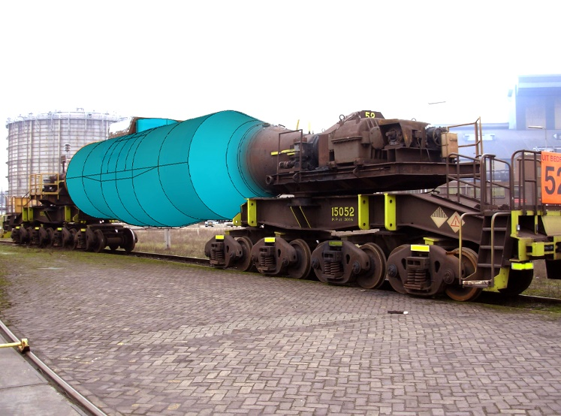 | 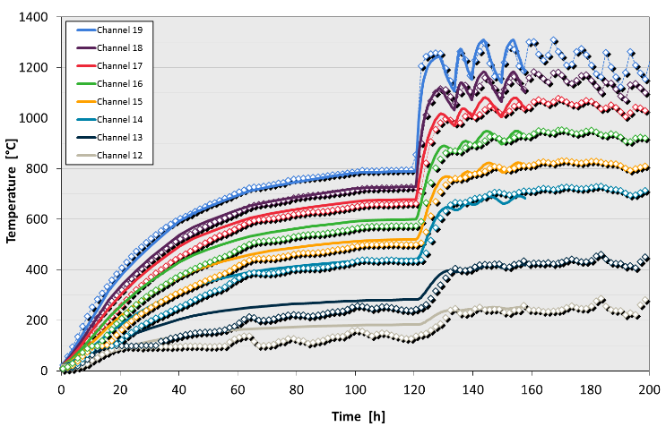
Figure 1. a) numerical model geometry overlaid on TSN torpedo ladle car; b) model validation with via thermocouple measurements <diamond markers are measured data and continuous lines are modelled data>.
The construction of physics’ model-based ROMs and the use of such models in TSN torpedo ladle digital twin is described in the next section.

Digital Twin Construction

To understand the torpedo ladle digital twin construction it is important to first understand the process in which the physical asset operates. A torpedo ladle carries hot metal from the blast furnaces to the basic oxygen steel (BOS) plant. Torpedo ladles have also the function of production buffer, synchronising the continuous production of the blast furnaces with the batch production mode of the BOS plant (fig. 2).

The torpedoes in the fleet usually present distinct ages. The age of the torpedo is relevant because it correlates to the refractories thicknesses inside the torpedo. They are the main responsible for the heating and cooling rates of individual torpedo ladles.

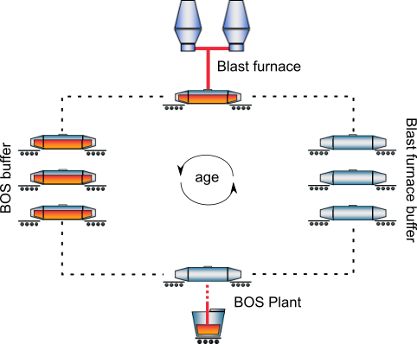
Figure 2. Diagram of torpedo ladle operation

The steps to build the ROM-based digital twin of a torpedo ladle are described in figure 3. The first step to build a ROM is identifying the governing parameters (parametrization). In the case of the present study, input parameters such as (i) torpedo age, (ii) hot metal inlet temperature, (iii) hot metal volume, (iv) the time the torpedo stays filled with the hot metal, (v) the time the torpedo stays empty, and (vi) the refractory mean temperature were defined. The output parameters were the refractory and the hot metal mean temperatures as function of time.

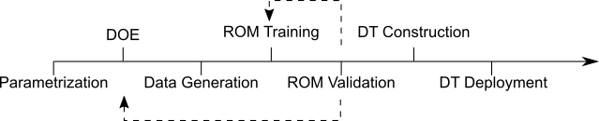
Figure 3. Steps used to build a digital twin of a torpedo ladle

With the governing parameters identified, design of experiments (DOE) was used to generate the training dataset, i.e., a smart distribution of design points within the training universe, to optimize the accuracy of the reduced order model. Additional data is also generated for the ROM validation. The data was generated by FEM thermal model of a torpedo ladle. In this model, a complex representation of the torpedo ladle is described.

A three-dimensional 1/4th symmetric transient thermal model was used. The material properties were considered as function of temperature. Natural convection was assumed on the torpedo shell, while internal convection and radiation were considered as boundary conditions of the wear lining and slag surfaces. Figure 4a represents an example of a FEM mesh and figure 4b shows a typical thermal gradient obtained with such model. As it can be seen, to optimise the computation time, symmetry was considered in the model.

a) | b)
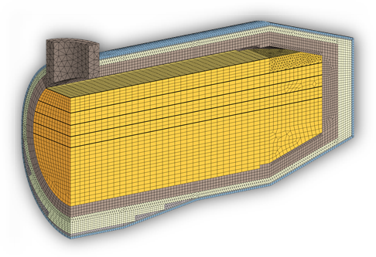 | 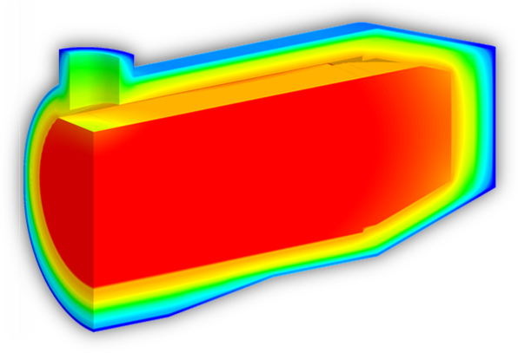
Figure 4. a) FEM mesh of ¼ of a torpedo ladle b) temperature gradient of a filled torpedo ladle.

Once the training and validation data were available, the ROM was built in the package Ansys Twin Builder®. In this package, a matrix containing the input parameters and the vectors with each output parameters are used to train the ROM. The ROM generation is based on the Singular Value Decomposition theory [3, 4].

The validation step is necessary to evaluate the ROM’s accuracy. Therefore, the part of the data not used in the training phase is used to validate the ROM. In total, three ROMs were built. Two ROMs were built to model the refractories temperature of a full and an empty torpedo, and one ROM was created to model the hot metal temperature.

The digital twin is made using the package Ansys Twin Builder® and combining the three ROMs in a single entity. Using a Python script, one can deploy the DT and get as outputs the refractory and hot metal temperatures as function of time for distinct scenarios. Figure 5 shows the comparison between the ROM and the FEM validation data for the refractory (5a) and hot metal (5b) temperatures considering distinct ages.

It can be seen an excellent agreement between the DT and FEM response. In terms of processing time, the DT generates a response in 0.05% of the time the FEM model takes, using the same hardware (5 seconds DT compared to 2.5 hours FEM). This gain in time allows the use of such technology in real time process simulation, as it will be discussed in the next section.

a)
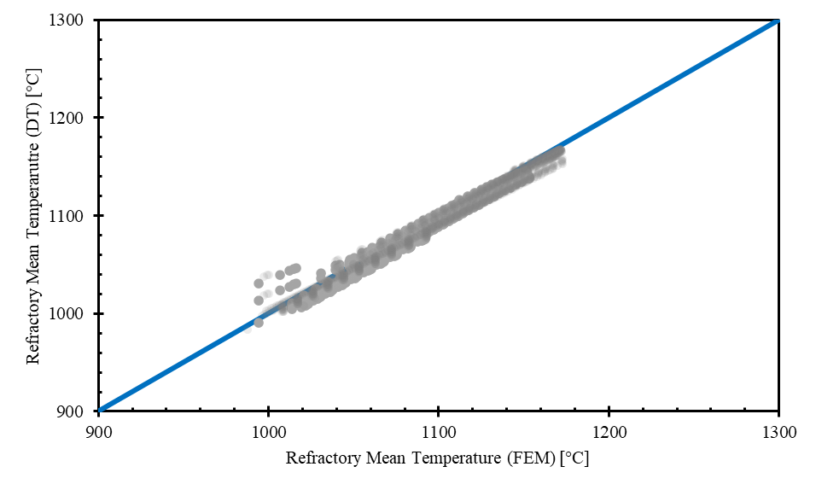

b)
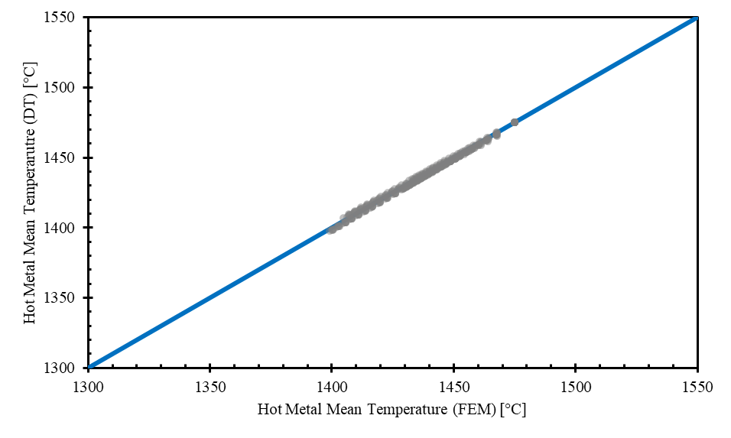
Figure 5. Comparison between the predicted refractory (a) and hot metal (b) temperatures using the DT and the FEM model.

DISCUSSION

Digital Twin Integration

In the previous sections, the steps taken to build a torpedo ladle digital twin composed by reduced order models trained with data from complex finite element method simulations were shown. The gains in scalability are evident, allowing the integration of such technology in real time process tracking and optimisation.

The use of a single DT per torpedo allows the construction of an online shadow model of the current fleet. As previously discussed, each torpedo presents a different age and has experienced different thermal cycles, affecting their heating and cooling rates and consequently the temperature of the hot metal delivered to the BOS plant.

The gains of integrating the DT for the whole torpedo fleet rely on global energy optimisation. An artificial intelligence agent is being trained by reinforcement learning to indicate to the operators what is the most efficient choice for a certain scenario. In this case, distinct objective functions can be evaluated and the disturbances in the circuit like change in production volume, different number of torpedo ladles available for use, etc, can be integrated in the analysis.

Next steps

The next steps of this project include the testing of the artificial intelligence agent in operational conditions (shadow mode). Finally, smart sensors could be integrated in the torpedo ladles streaming live data to the ROM/DT. E.g., including weather or seasonal effects or to establish a better relation between torpedo age and refractory thicknesses. Including the other equipments in the optimization loop will allow for an integrated operation of the distinct plants.

CONCLUSIONS
This study investigated the construction of a digital twin of a torpedo ladle using Ansys Twin Builder. The digital twin is composed by three reduced order models trained with data from complex finite element models validated with thermocouple measurements. It can be concluded that the construction and deployment of a digital twin based on physics simulation data is achievable. The computation times gains of using DT compared to traditional FEM, while keeping an excellent result agreement enables the real-time process optimization. The calculated improvements in energy efficiency and refractory lifetime motivates the continuation of the project and its extension to other equipment in the production chain.

REFERENCES
1. M. Segovia, J. Garcia-Alvaro, “Design, Modelling and Implementation of Digital Twins”, Sensors, 22, 5396 (2022).
2. P. Van Beurden, J. Liefhebber, P. Sentveld, F. Kerkhoven, “On the Thermal Management of Torpedo Ladle Car Logistics of Tata Steel in IJmuiden”, Proc. UNITECR 2019, pp.365-368 (2019).
3. M. Calka et al., “Machine-learning based model order reduction of a biomechanical model of a human tongue”, Computer Methods and Programs in Biomedicine, vol. 198 (2021).
4. X. Hu et al., “A transient reduced order model for battery thermal management based on singular value decomposition”, in IEEE Energy Conversion Congress and Exposition (2014).

